**BUSA526: Database Management**

**Project 1**

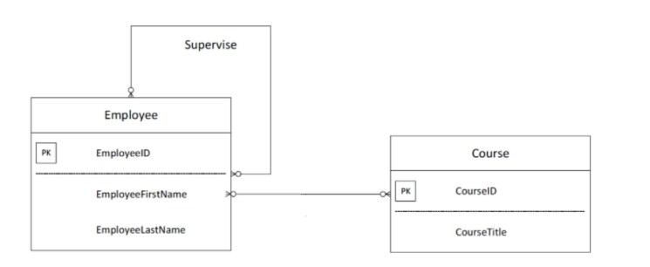**Question 1.** Create a database named “EMPLOYEE INFO” based on the following ERD. Recall that this is ERD and you need to convert it to relational model and then normalize it before implementing in SQL. Also, make sure that you are using correct data type for each attribute. 2. Enter at least five records for each table.

**Question 2.** Download the Projectdata.SQL and run it in MySQL. Now, write a query that deletes duplicated rows. You need to keep only one of the duplicated rows.

**Question 3.** Download the world.sql and run it in MySQL. Now based on this database write query that shows

1. The most populated city in each country
2. The second most populated city in each country
3. The most populated city in each country
4. The most populated country in each continent
5. The most populated continent
6. The number of people speaking each language
7. The most spoken language in each continent
8. No. of languages that are official languages of at least one country
9. The most spoken official language based on each continent
10. The country with the most (# of) unofficial languages based on each continent
11. The countries where their capital is not the most populated city in the county
12. The countries with population smaller than Russia but bigger than Denmark